**Halloween Masks Are Overrated**

***Forensics***

**Challenge:**

My friend who is into aliens, has been acting weird lately.

Ever since he learned about some weird technique musicians used in the 1980s, he has been losing his mind.

The last message he sent me was this image of an alien mask, it might one of the masks from his big halloween mask collection.

Can see if there is anything in this image he sent me?

Attached - mask.jpg

**Approach:**

We first binwalk the image and see there’s a zip archive in it with flag.mp3 file. We extract it using binwalk:

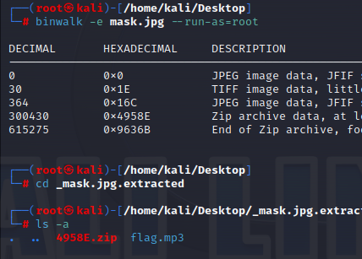

We hear the audio and it looks like a reverse audio, so we use an online tool to reverse it back.

If we listen closely to the audio, there’s a heavy voice spelling the flag encrypted with caesar cipher. We decode it and get the flag:

**Flag: NICC{B4CKM4SKING_IS_COOOL}**

Congrats!!

Happy Hacking!